Delhi Metro Navigator - User manual

Dear User,

This is the Delhi Metro Navigator and I am here to help you find your best way through Delhi metro.

Ever travelled through Delhi Metro? What was it like? I am sure when it was your first time in the Metro it would surely have been confusing and if you are a new user then

“Worry Not Citizens, cause I am here” ⁓ Almighty

Introductions

I am a user-friendly program created by **Chirag Sugla** to help people easy navigate easily in Delhi Metro. I am created using Python IDLE 3.10.3. The special thing about me is that I was originally a learning project and am made by using only basics of python language.

Note By The Creator

Hey guys this is Chirag. I created The Delhi Metro Navigator. For me it was both fun and a learning experience. I hope it will assist you and you will have a fun time using it.

How To Use

1. Open the program file in python.

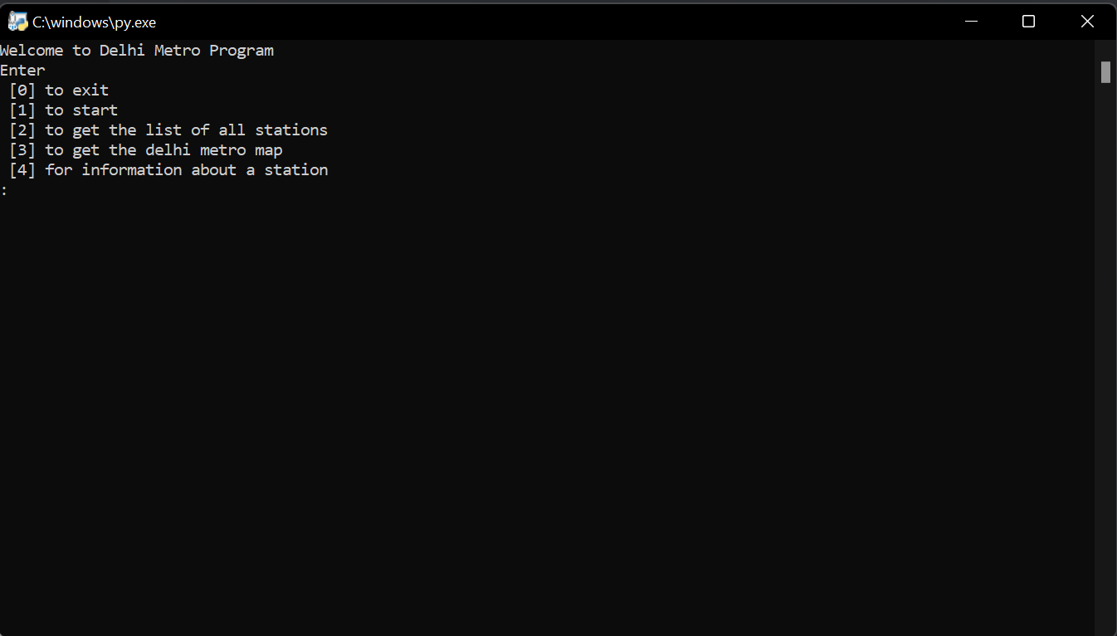

1. Enter 1 to start.

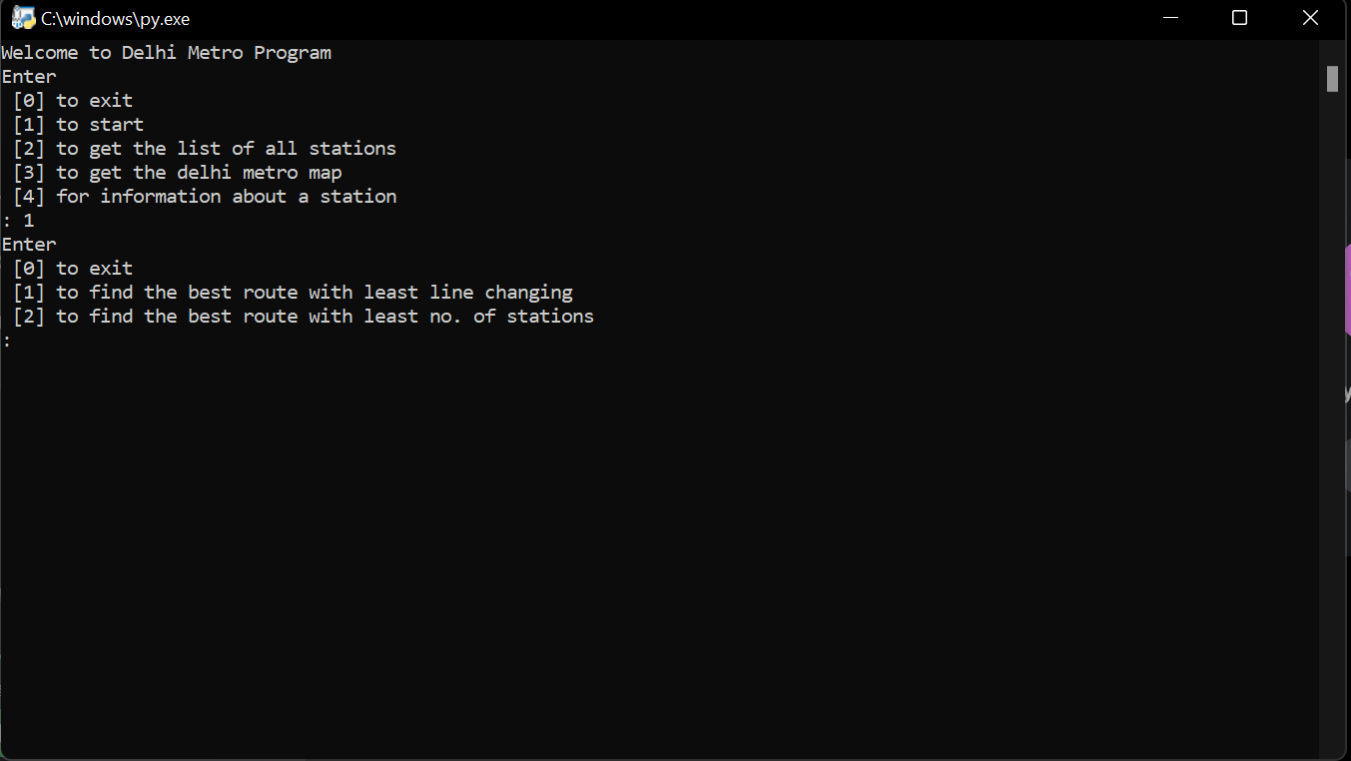

1. Enter 1 again to find the shortest route with changing least number of lines (preferred way)

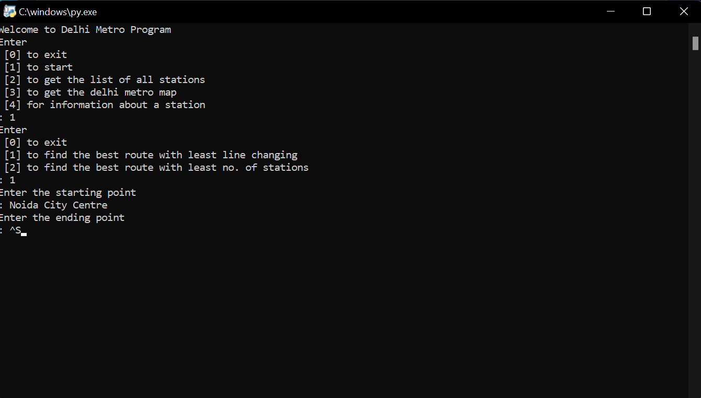

1. Enter the starting and the ending point and there you go.

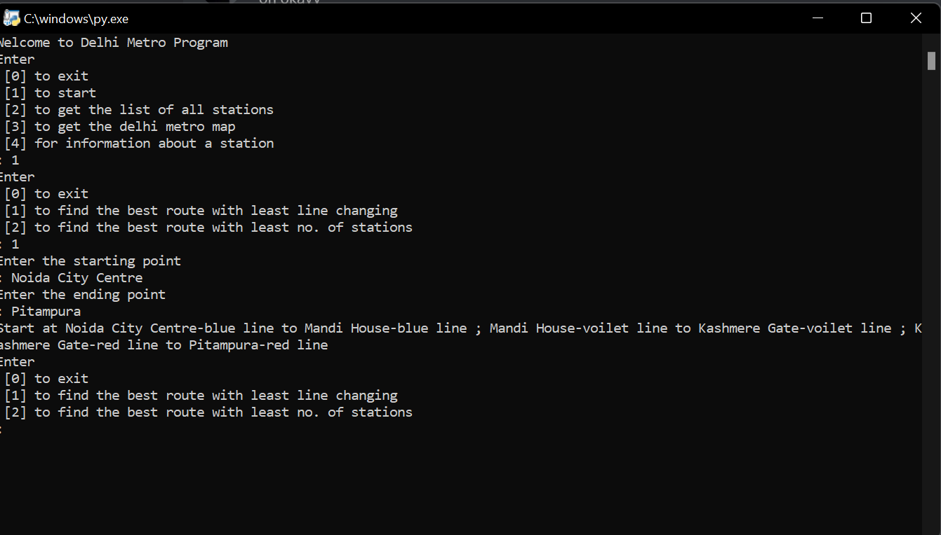

1. You can also get the best route by least no. of stations to cover.

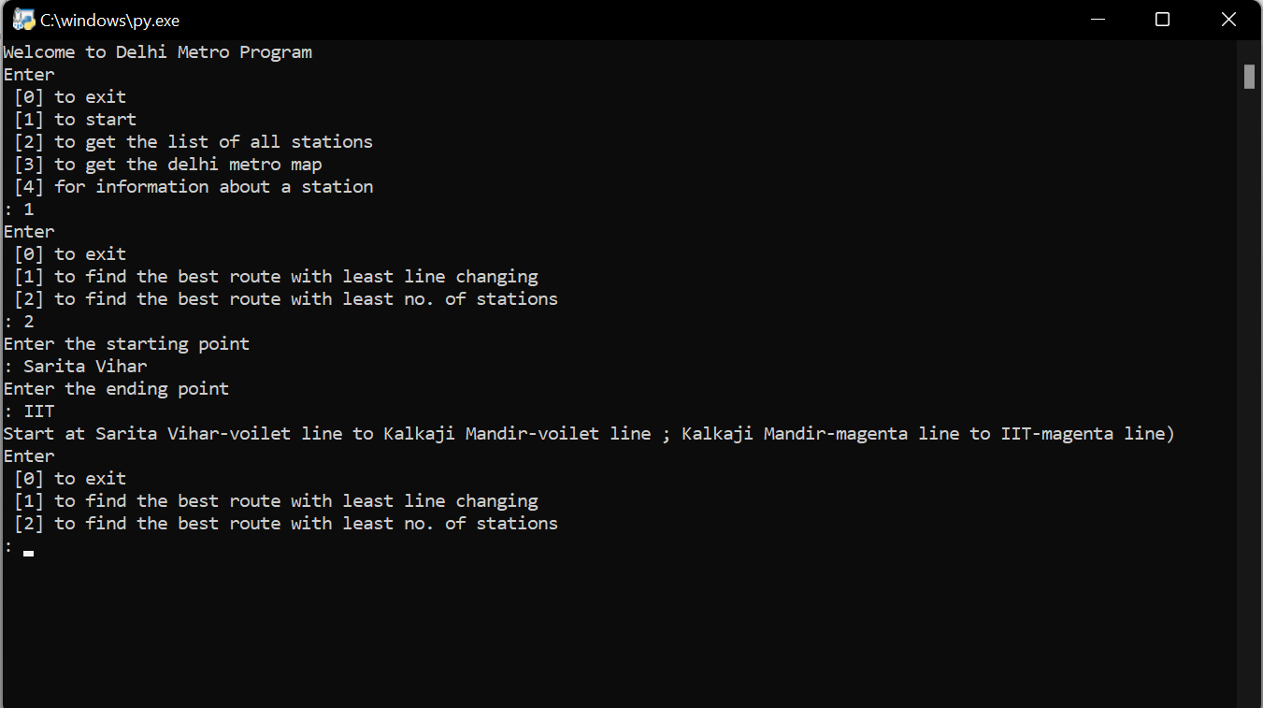

1. Follow the code and you can discover it further.

Hope I was of some use to you and next time you travel in the metro You won’t get lost. I will take my leave now. I wish you will enjoy your next ride.

Delhi Metro Navigator

Credits: Chirag Sugla